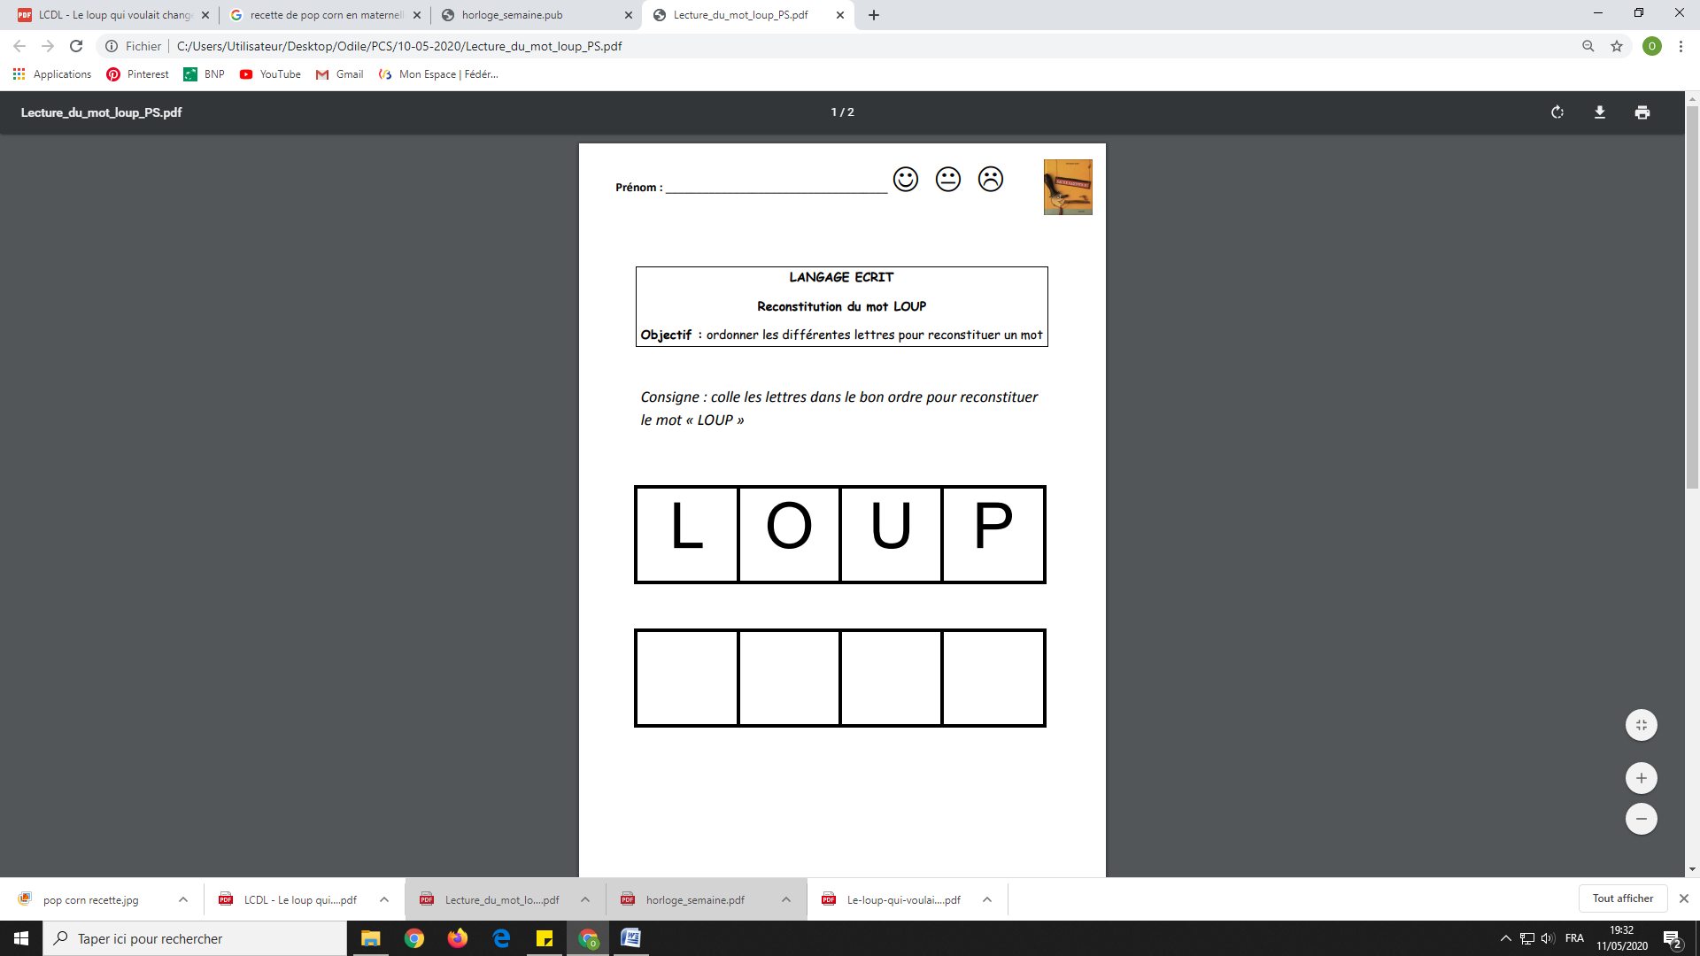

|  |  |  |  |
| --- | --- | --- | --- |
| P | U | L | O |

✄